Latest Project

1. Opus Park Appartment – Sentul (2019 – 2020)

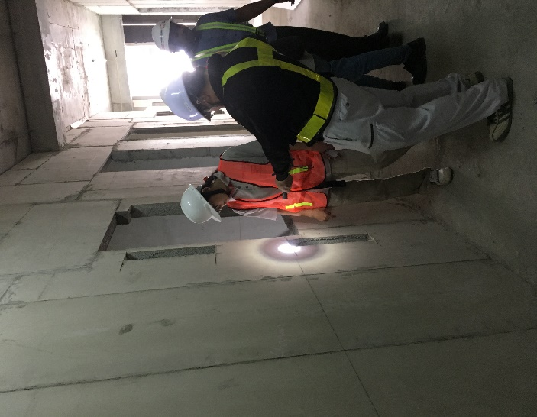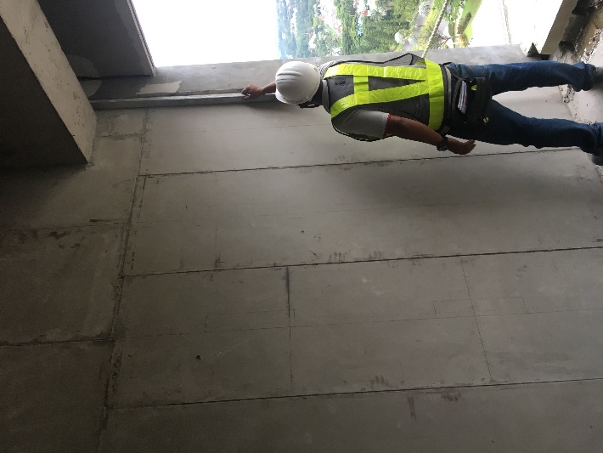

Project start on July 2019 until February 2020.

Involved as an Assistant Project Manager which help Japanese Project Manager.

My job description for this project were:

1. Checking and reviews document from Quality control division
2. Purchasing for sub-material and tools
3. Review for Progress based on schedule (s-curve)
4. Developing installation method (Shop drawing)
5. Coordination with main contractor
6. Foreman trainee for wall panel installation (provide supporting presentation)
7. Make a Daily report, Weekly Report, and Monthly report. (directly to Project manager and all directors)
8. Hilton Hotel – Jakarta (2019)

Involved as Technical Support and Drafter for Mock Up. Mock up location was not common, it located on 29th floor at office building. So we should provide installation method with carefully.

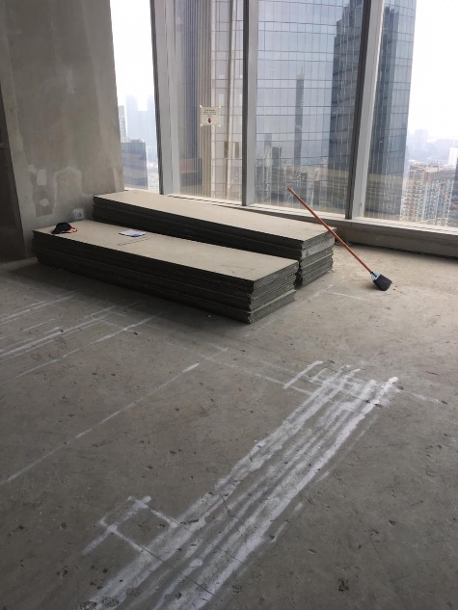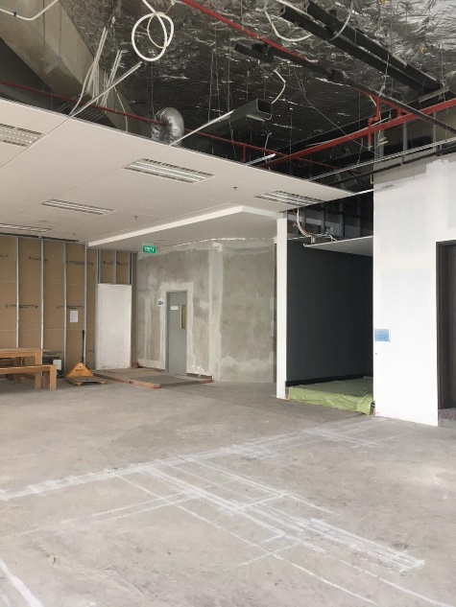

1. Meikarta District 1 Mock Up (2019)

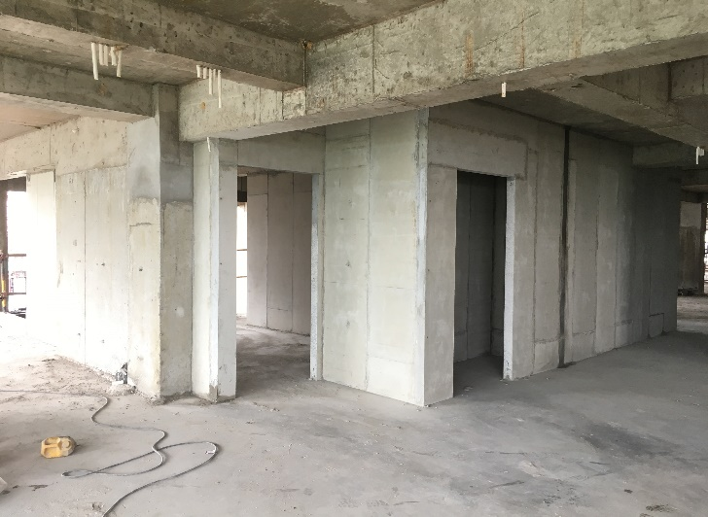 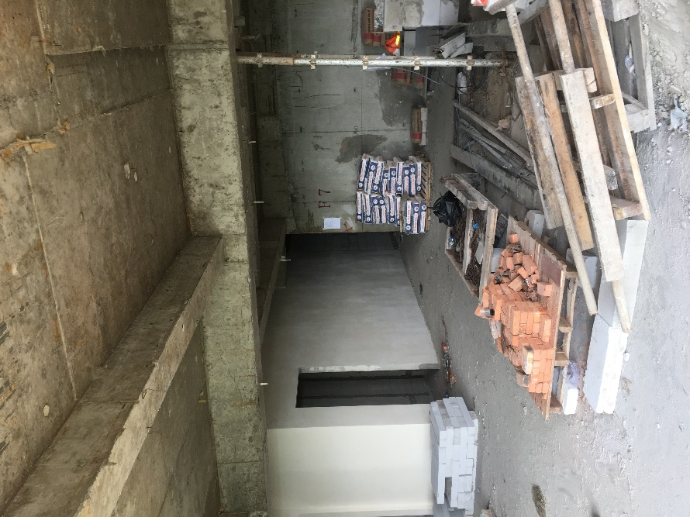

Mock Up for apartment unit using wall panel. Mock up duration was 7 days for wall installation + 2 days for skim coat finishing. Start on Middle of March 2019

Involved as a Supervisor Mock Up which has a responsibilities:

1. Provide shop drawing
2. Provide sub-material and tools (purchasing)
3. Quality control for installation
4. Reviews Foreman workability
5. Tokyo River Side Mock Up (2019)

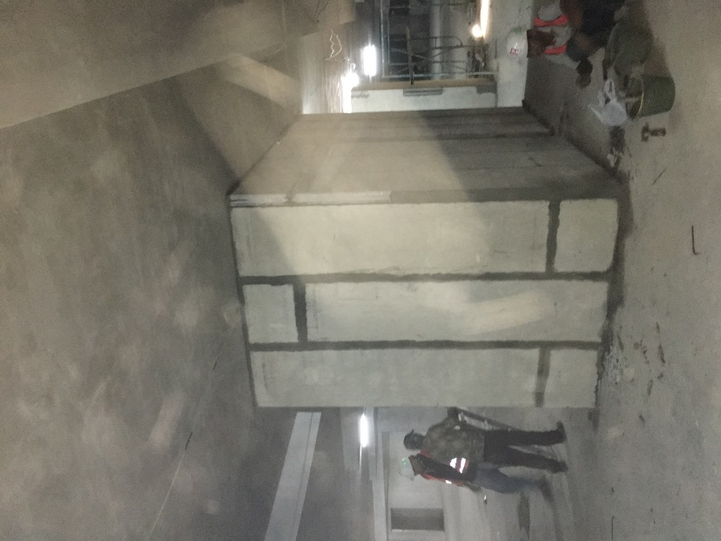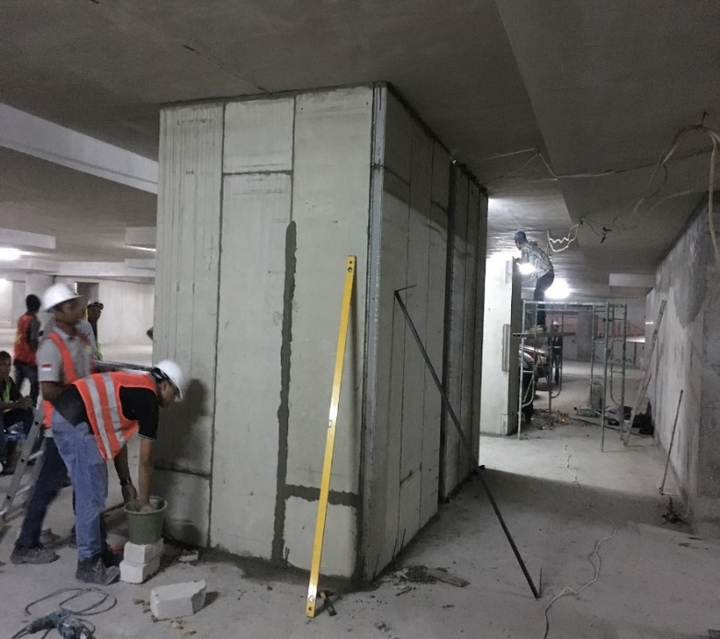

Mock Up for L wall using wall panel. Mock Up location was on Menara Jakarta (basement). The project start on May 2019 within 1 day installation, 5 days curing, and 1 days finishing. Involved as a Supervisor Mock up, which has responsibilities:

1. Provide shop drawing
2. Provide sub-material and tools (purchasing)
3. Quality control for installation
4. Reviews Foreman workability
5. Day n Night Hotel – Kebun Jeruk (2018 - 2019)

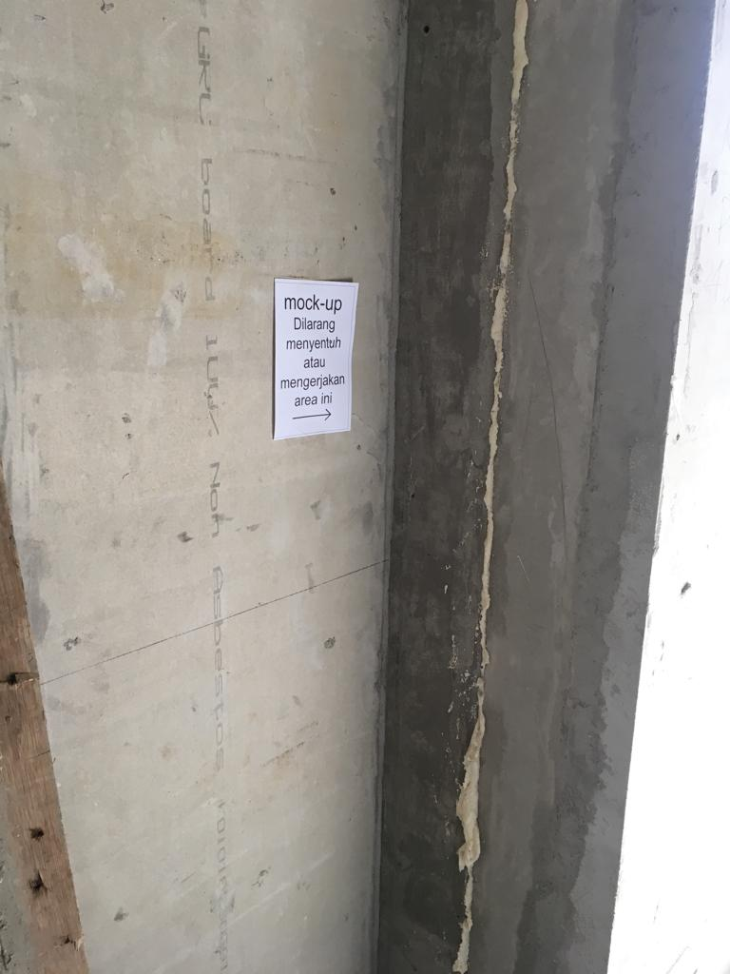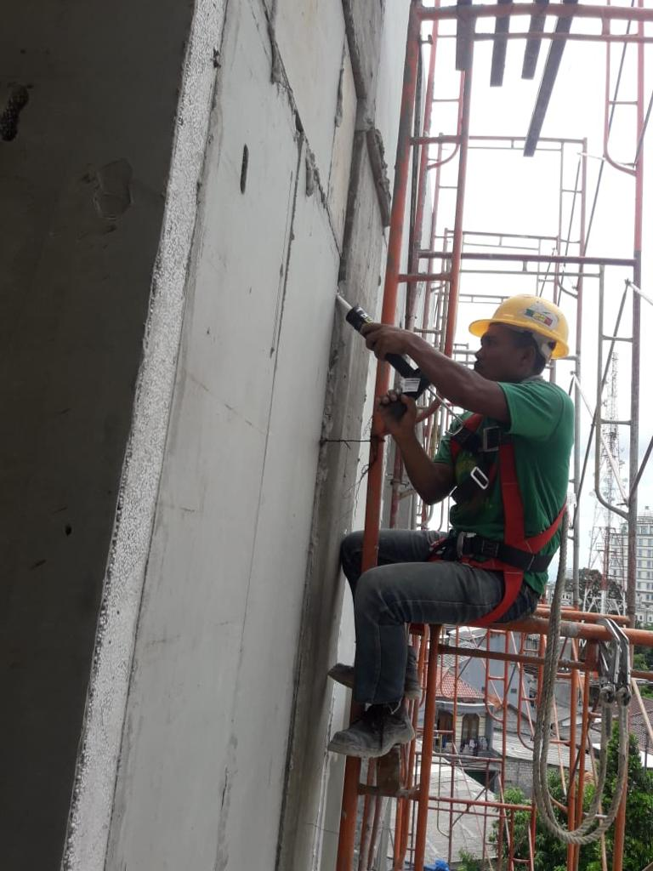

Involved as a Junior Research and development, for finding the suitable repairing method for crack.

1. Drafter for wall panel Installation
2. Hilton Hotel – Jakarta (2019)

Shop drawing for mock up

1. The Pakubuwono Menteng – Jakarta (2019)

for Wall panel installation at Basement area (perimeter wall).

1. Gunze Factory – Vietnam (2019)

For wall panel installation at factory